Tail Rhyme

🔹 What is Tail Rhyme
# Source: Chatgpt (GPT-4-turbo) at [8/2/2025]
⚠️ Tail rhyme is a rhyme scheme, not a linguistic type of homograph.
However, homographs may appear in tail rhyme if pronounced to match the rhyme.

✅ Definition of Tail Rhyme
# Source: Chatgpt (GPT-4-turbo) at [8/2/2025]
Tail rhyme refers to the rhyming of the final words (tails) of lines in a stanza. It typically follows a repeated end-rhyme pattern, especially where every third line rhymes.
🟨 Common patterns:
- AAB CCB
- AABA BBCB
- Sometimes looser, as long as rhymes occur at line ends

🧠 Key Features
# Source: Chatgpt (GPT-4-turbo) at [8/2/2025]
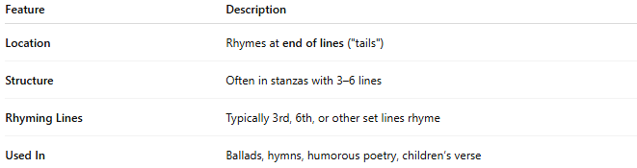
Feature | Description
Location | Rhymes at end of lines ("tails")
Structure | Often in stanzas with 3–6 lines
Rhyming Lines | Typically 3rd, 6th, or other set lines rhyme
Used In | Ballads, hymns, humorous poetry, children’s verse

📝 Example of Tail Rhyme (AAB CCB):
# Source: Chatgpt (GPT-4-turbo) at [8/2/2025]
A: The sky grew dark with clouds so wide
A: The lightning flashed and could not hide
B: A thunderclap rolled through the plain
C: The trees all bent, their roots exposed
C: The storm went on and never closed
B: A pounding rhythm, endless rain
- wide / hide, exposed / closed = paired rhymes
- plain / rain = repeating tail rhyme every third line
✅ This is tail rhyme.

🧪 Using Homographs in Tail Rhyme
# Source: Chatgpt (GPT-4-turbo) at [8/2/2025]
Homographs can appear at the line endings in tail rhyme if they are used with the correct pronunciation:
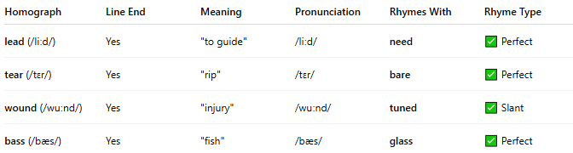
Homograph | Line End | Meaning | Pronunciation | Rhymes With | Rhyme Type
lead (/liːd/) | Yes | "to guide" | /liːd/ | need | ✅ Perfect
tear (/tɛr/) | Yes | "rip" | /tɛr/ | bare | ✅ Perfect
wound (/wuːnd/) | Yes | "injury" | /wuːnd/ | tuned | ✅ Slant
bass (/bæs/) | Yes | "fish" | /bæs/ | glass | ✅ Perfect
❗ Tail rhyme depends on sound, not spelling.
Homographs pronounced differently from their rhyme partners will break the rhyme.

✅ Summary
# Source: Chatgpt (GPT-4-turbo) at [8/2/2025]
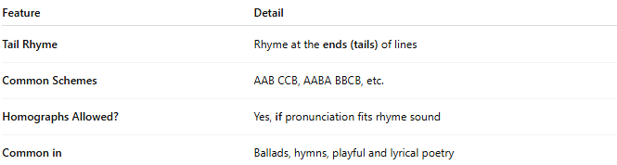
Feature | Detail
Tail Rhyme | Rhyme at the ends (tails) of lines
Common Schemes | AAB CCB, AABA BBCB, etc.
Homographs Allowed? | Yes, if pronunciation fits rhyme sound
Common in | Ballads, hymns, playful and lyrical poetry

